**Assignment – 3**

|  |  |
| --- | --- |
| Student Name/ID Number: | Muhammad Kemal/BDSE-0922-084 |
| Unit Number and Title: | Develop Project Design |
| Academic Year: | 2022 |
| Unit Assessor: | Arvinder Kaur |
| Project Title: | Project Proof Of Concept (POC) |
| Issue Date: |  |
| Submission Date: |  |
| Internal Verifier Name: |  |
| Date: | July 2023 |

|  |
| --- |
| **Learner declaration** |
|  |
| I certify that the work submitted for this assignment is my own and that research sources are fully acknowledged.  Student signature:  Date: July 2023 |

**MEALS ON WHEELS**

**Assignment 3 - Project Proof Of Concept (POC)**



**MUHAMMAD KEMAL (BDSE-0922-084)**

**SOFTWARE ENGINEERING**

**LITHAN EDUCLAAS**

**(2023)**

**Use Case Diagram**

The high-level features and scope of a system are described in use-case diagrams. These diagrams also show how the actors in the system interact with one another. Use cases and actors in use-case diagrams demonstrate what the system accomplishes and how the actors interact rather than describing how the system operates internally.

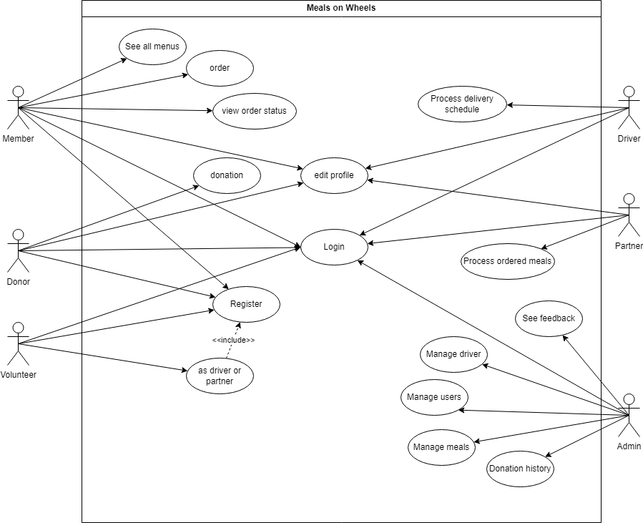

Meals on wheels

1. Login screen   
   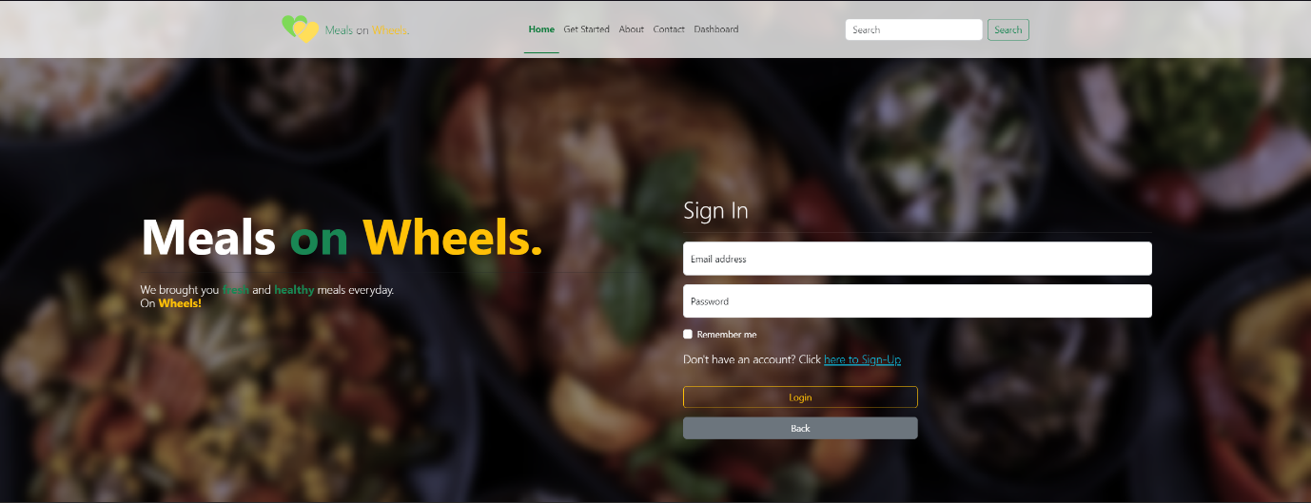
2. Register Screen  
   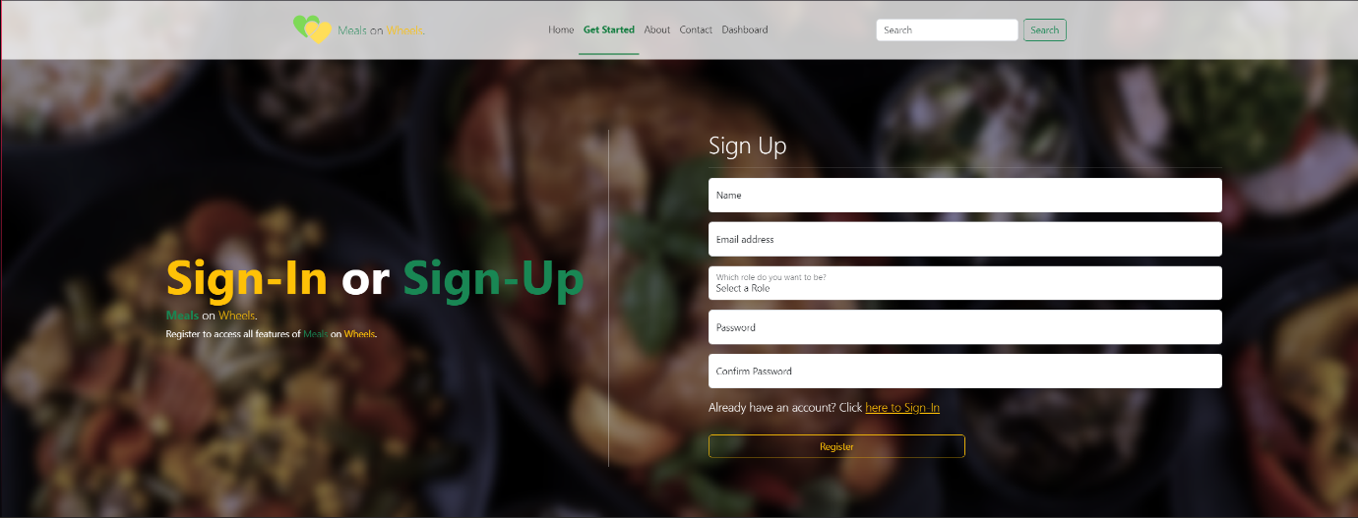
3. Landing Page   
   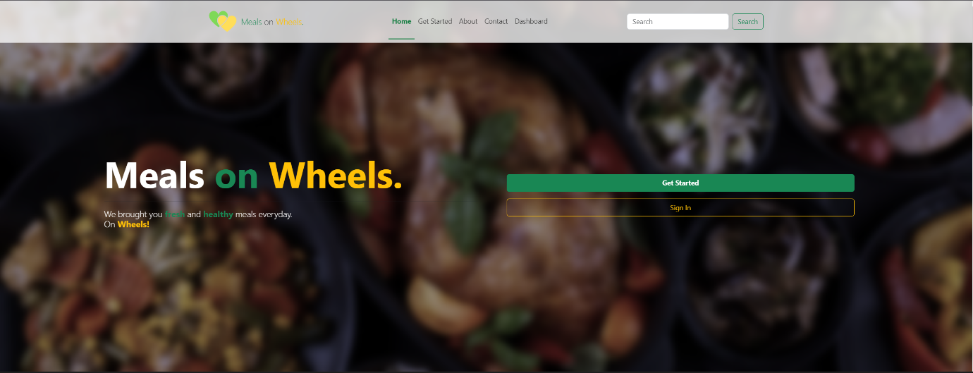  
   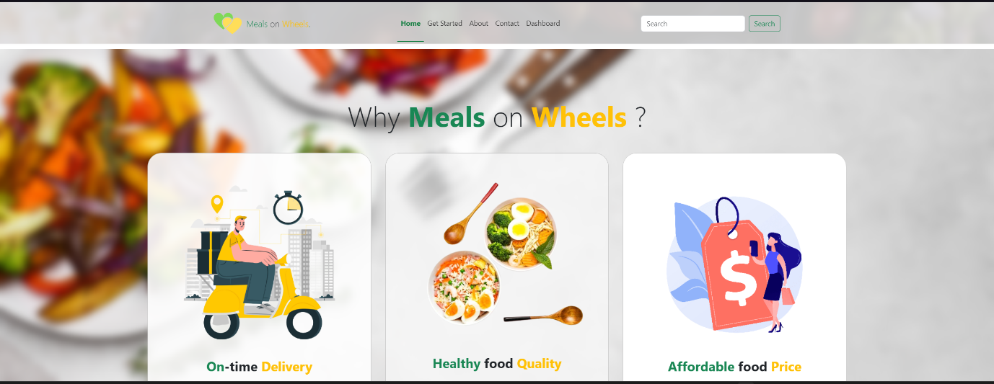  
   S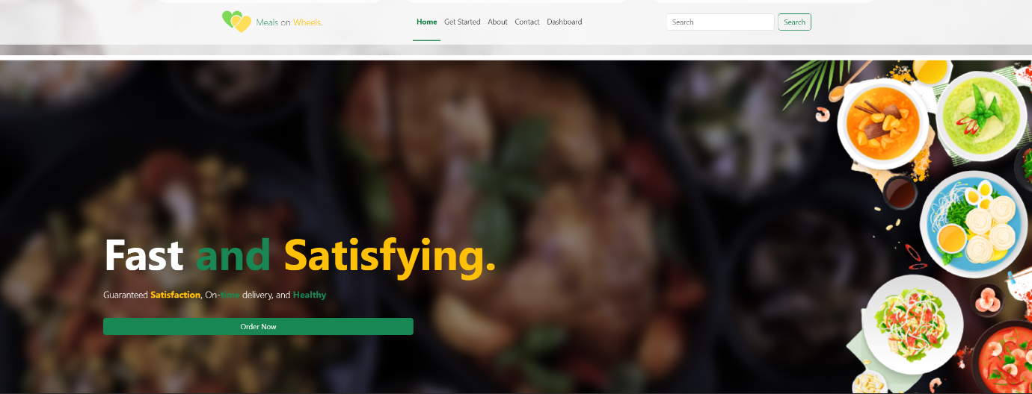
4. About Us Page  
   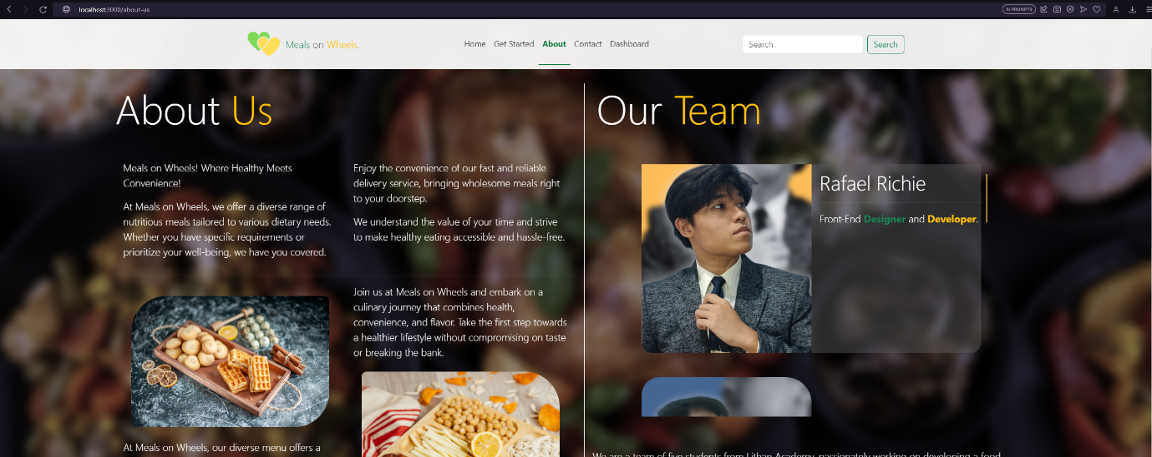  
   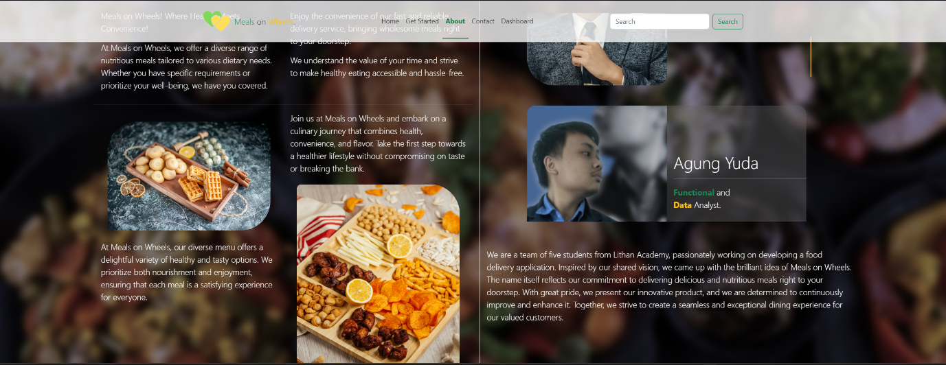
5. Contact Us Page  
   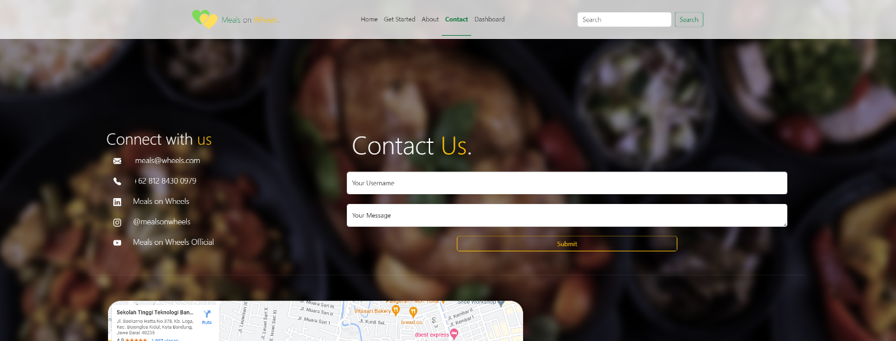  
   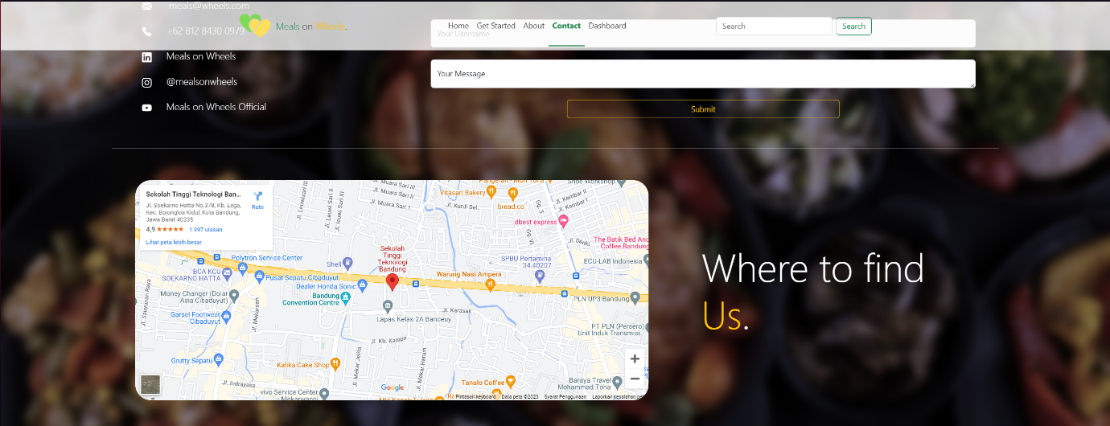
6. Member Dashboard

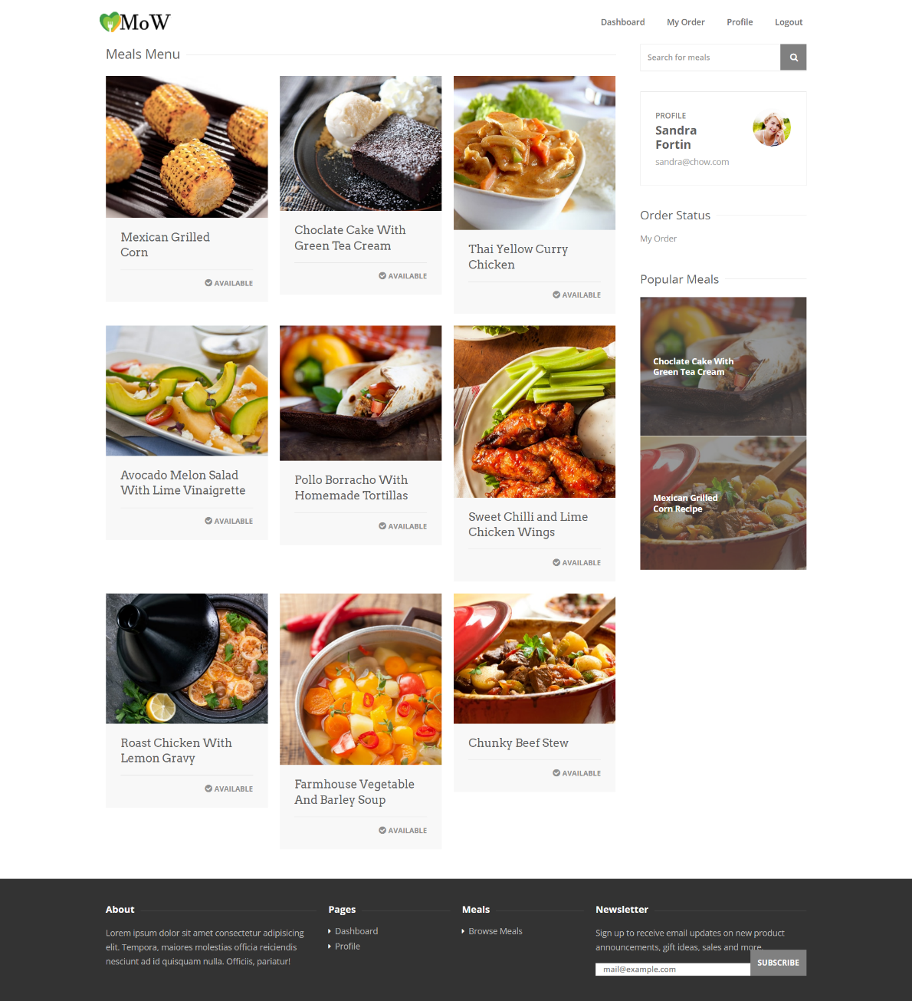

1. Member Meals Details Page

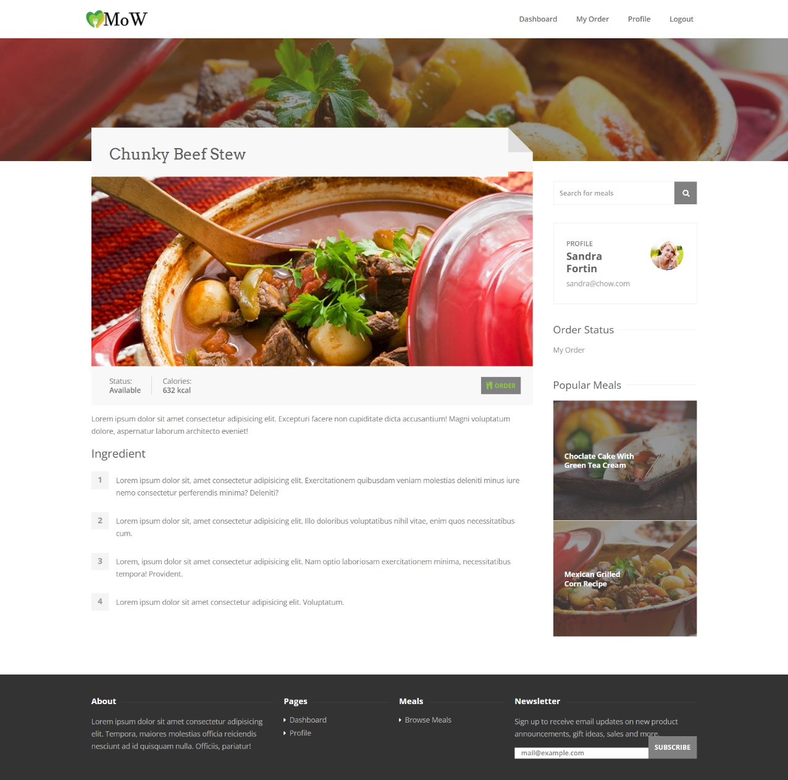

1. Member My Order Page

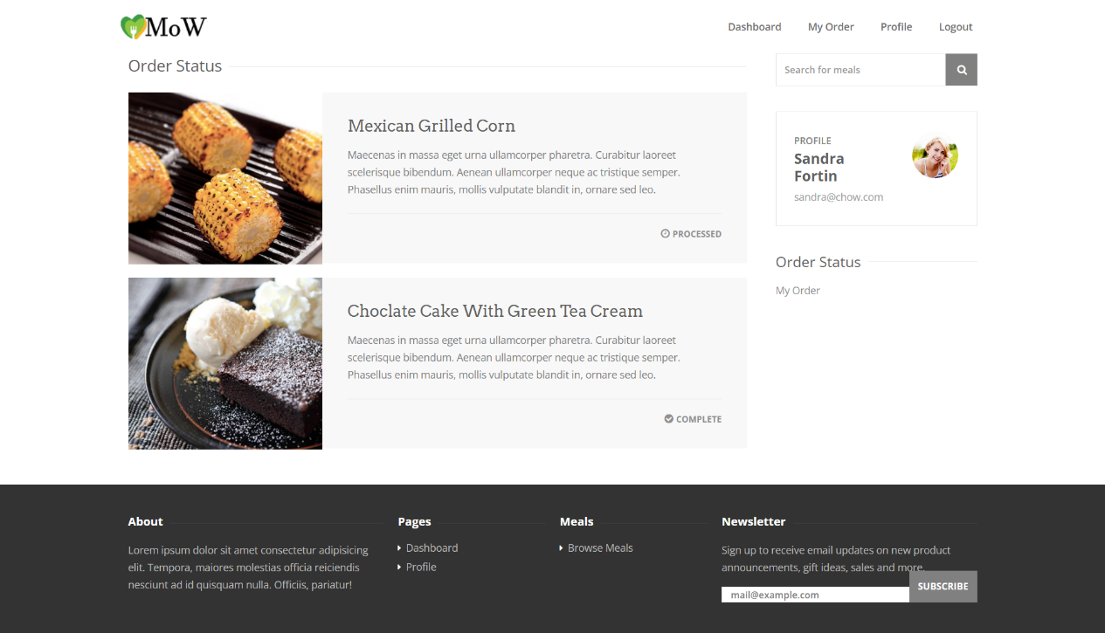

1. Member Profile Page

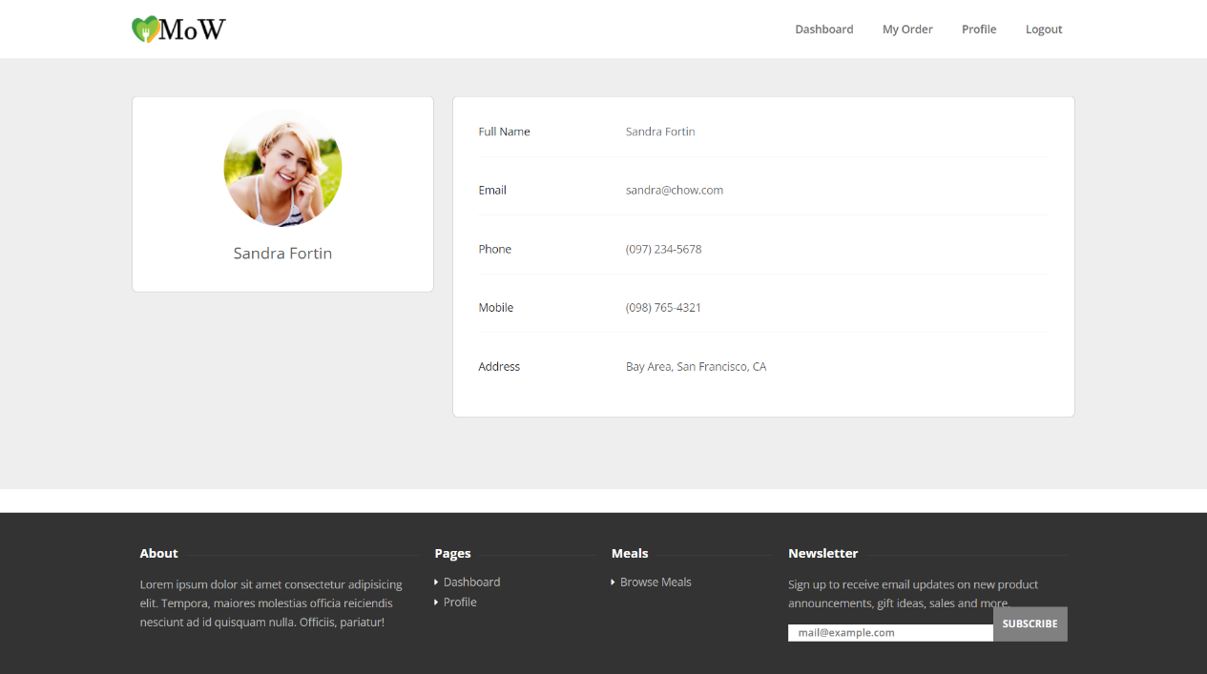

1. Admin dashboard

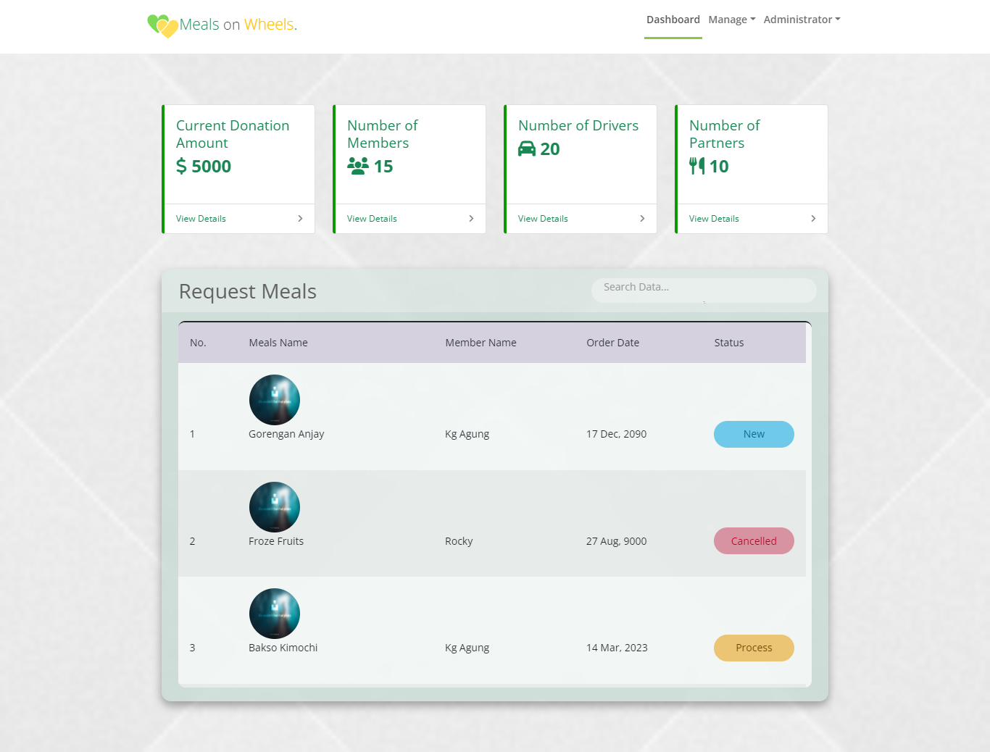

1. Admin Manage Meals

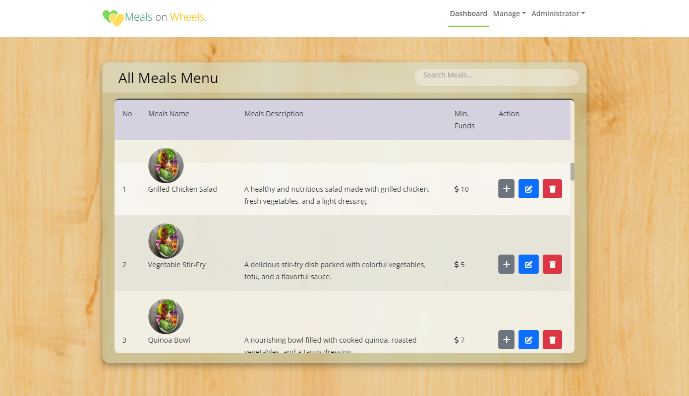

1. Admin Manage Donations

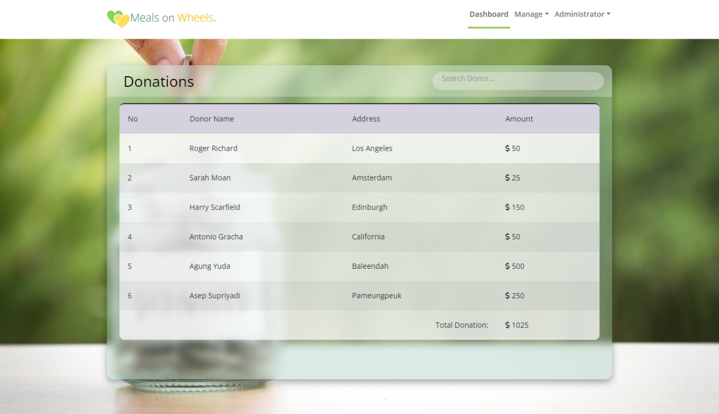

1. Admin Manage Members

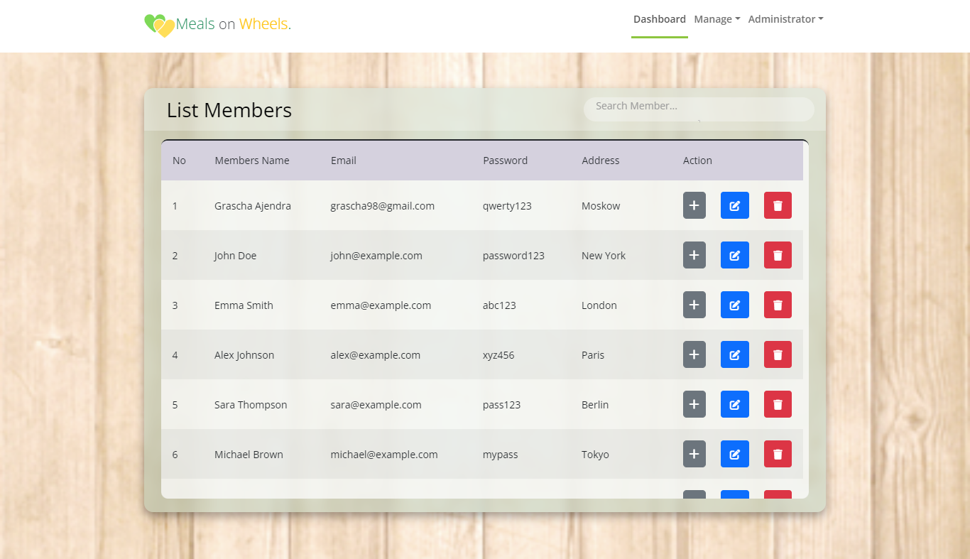

1. Admin Manage Order

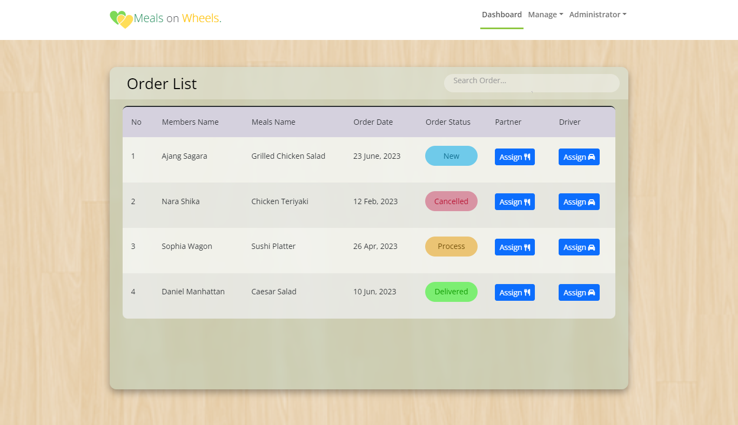

1. Donor Dashboard

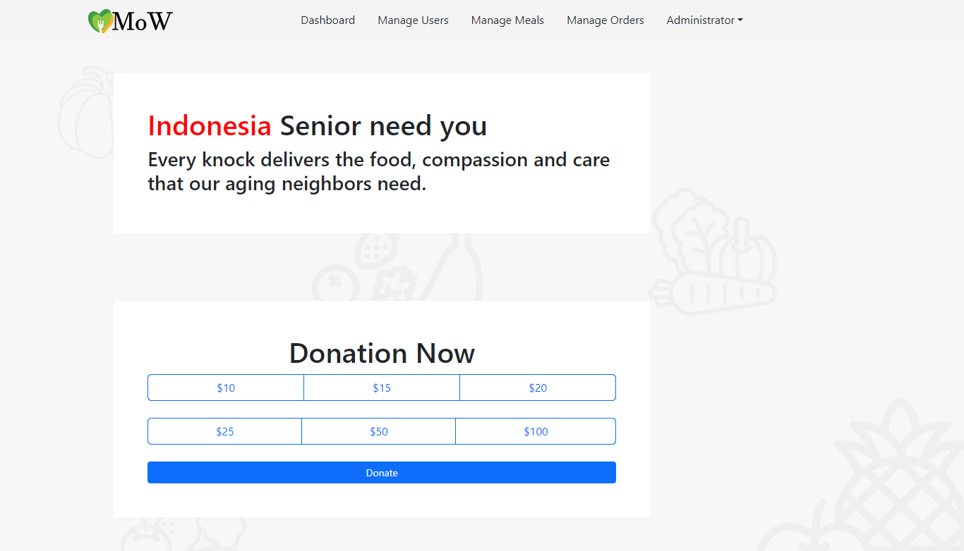

1. Partners dashboard

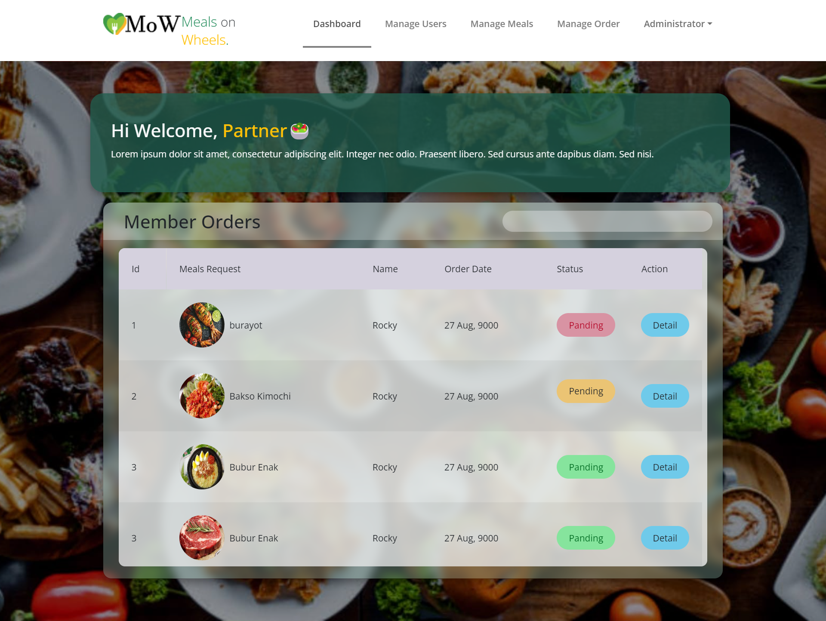

1. Caregivers Dashboard  
   